Instrument Raw Data Storage (IRDS) is a role-based access system that helps users manage files and instruments. This application tackles the issues in storage of raw data files by acting as a transfer medium between an Instrument PC and a Central Repository. IRDS is classified as non critical and non-regulated application and is designed to provide automated offline raw data file storage capability to the ADD Research Organization.

Application SP ID is 14454.

**Please note:** Do not use the Application Handbook to identify the latest owners (Application, Support or Business).   For BTS IT Support Owner: Access the application portfolio management tool (HOPEX) for current support owner names.

* 1. Table of Contents

|  |
| --- |
| 1.0 Overview  1.1 Table of Contents  1.2 Purpose  1.3 Scope  1.4 Responsibilities  2.0 Definitions  3.0 Requirements  3.1 Performance Requirements  3.2 Service Requirements  4.0 Business Process Overview  4.1 Business Process Workflow  4.2 Business Module Description  5.0 Application Overview  5.1 System Architecture  6.0 Application Onboarding Requirements  6.1 Application Level Training  6.2 Application Access & Onboarding  7.0 Scope of Maintenance Operations  7.1 In Scope Activities  7.2 Out of Scope Activities  7.3 Site and Regional Differences  7.4 Vendor Agreements  7.5 Support Dependancy Matrix  7.6 Key Contacts  7.7 Knowledge Repository |

1.2 Purpose

This document serves as the knowledge transition for IRDS application. It provides the overview of the Support Activities, Application Architecture, Server details, Support SLA’s etc.

1.3 Scope

The scope of application support shall include the following:

**General:**

* Handling ITSM tickets including Incidents and Service Requests

**Application:**

* Resolution of functional issues or providing information/clarification on IRDS functionality.
* Co-ordination with corresponding teams for resolution of issues related to databases and servers.
* Application checkouts post server restarts as a part of wintel team’s server maintenance.

**Database**:

* Co-ordination with the team for any CPU/Memory/backup/database restore and other realated issues.

**Monitoring:**

* Standard automated monitoring of Database and Servers.

1.4 Responsibilities

|  |  |
| --- | --- |
| **Roles** | **Responsibility** |
| Application Administrator (Admin) | An Admin can access all of the modules in the application   * Add a new user/another Admin * Add/Modify existing user details * Delete/Disable users * Add a new Department. * Add/Modify department details * Delete/Disable department * View Audit Trail * Create an Instrument * Enable an instrument file path * Edit instrument details * Transfer Files to Central Repository * Restore files to a selected instrument * Designate files for deletion * Extend the retention period of files in Central repository * Check the count and volume of files/folders in the Central repository |
| IRDS Author/Laboratory Managemer | An Author/Laboratory Manager can access the following modules in the application.   * View Audit Trail * Create an Instrument * Edit instrument details * Transfer Files to Central Repository * Restore files to a selected instrument * Designate files for deletion * Extend the retention period of files in Central repository   Exceptions:   1. Author/Laboratory Manager will not be able to set an Instrument File path while creating an Instrument 2. IRDS application permits only a user with Admin role to create another user/department in the system. However, under ‘Create Instrument’ section of ‘Instrument Management’, user with Author/Laboratory Manager role can add a new Laboratory Manager/Laboratory Manager Department into the system. 3. No user in IRDS can modify/delete audit logs |
| IRDS General User | General User role is designed to only view the raw data files stored in Central Repository at any point in time. S/he can do this by visiting the ‘File Restore’ tab and viewing the list of files in the Central repository |
| Oracle DB Team | * Database related maintenance activities and Database Change Request * Periodic Backups of the database. * Restoring Backup from the last backup file, in case of data loss. |
| Wintel Team | * Responsible for Memory Management, CPU Utilization, Availability and manintenance of application and database servers |
| Application Support team | * Resolution of functional issues or providing information/clarification on IRDS functionality. * Co-ordination with corresponding teams for resolution of issues related to databases and servers. * Application checkouts post server restarts as a part of wintel team’s server maintenance. |



|  |  |
| --- | --- |
| Term | Definition |
| ADD | Abbott Diagnostic Division |
| CR | Change Request |
| DB | Database |
| ESAM | Enterprise Security Access Management |
| GAA | Global Access Admininstration |
| HTTP | Hyper Text Transfer Protocol |
| IE | Internet Explorer |
| IIQ | Identity IQ |
| IPDR | Incident/Problem/Defect Report |
| IRDS | Instrument Raw Data System |
| ITSM | IT Service Management |
| LAN | Local Area Network |
| LDAP | Lightweight Directory Access Protocol |
| RDBMS | Relational Database Management System |
| REST | Representational State Transfer |
| SBM | Serena Business Manger |
| SME | Subject-Matter Expert |
| SMTP | Simple Mail Transfer Protocol |
| SP2 | Service Pack 2 |
| TCP/IP | Transmission Control Protocol/Internet Protocol |



### Web Server Requirements:

* The user interface of the application consists of Angular pages. These are located and executed on Tomcat server 9.0.
* Oracle client serves as the database server for IRDS system

### Client Requirements

* IRDS application is an intranet-based web application and shall be available from IE/Chrome browsers on Abbott-connected workstations
  1. Performance Requirements
* IRDS System shall allow up to 50 concurrent users to access the system.
* The System shall be accessible 7 days a week, with exception of scheduled maintenance, emergency software releases, and hardware maintenance.

3.2 Service Requirements

|  |  |
| --- | --- |
| Service Requirements | Requirement Details |
| Users Groups or Department | Admin, Author/Lab manager, General user |
| No. of Users using the applications | 2 |
| Location of the users | US- Franklin County, Lake County |
| No. of Sites where users are using the application | 2 |
| No. of Concurrent users during the application | 50 |
| Licences | No Licence constraint |

* 1. Business Process Overview

The IRDS applications will be developed for tagging, pulling and storing instrument raw data files in a central storage location. Raw data files generated by the research organization are currently hosted on research instruments with limited storage capacity. The ADD research team store raw data files on USB drives or deleting files altogether- a practice that is not secure, compliant with retention policies and could increase costs by forcing scientists to re-execute experiments. The IRDS solution provides OneDX Research with a standard method for tagging, pulling and storing instrument raw data files in, that is secure and controlled, compliant with retention requirements, efficient (Eliminate manual file management activities with automation), cost effective (Eliminate capability to reduce duplication and re-analyze).

The application provides the following capability to the ADD research organization

* Instruments PCs with raw data files generated by research laboratory instruments will be pulled by the application on a scheduled /or on-demand basis,
* Files will be copied to a central storage location
* Files may be restored to a selected location on user demand.

4.1 Business Process Workflow

The IRDS Application data interface model and its corresponding relation with appropriate databases be per the Process Model diagram below:

The following activities will be the part of the Process Flow

* The Instruments are created on the UI
* On the File Transfer Screen, we can select the files for the selected Instrument
* The Selected files can be scheduled, and the scheduler will copy the files from the Instrument to the Central Repository
* Depending on the success/failure of the file Copy Activity the respective Owners will be notified.

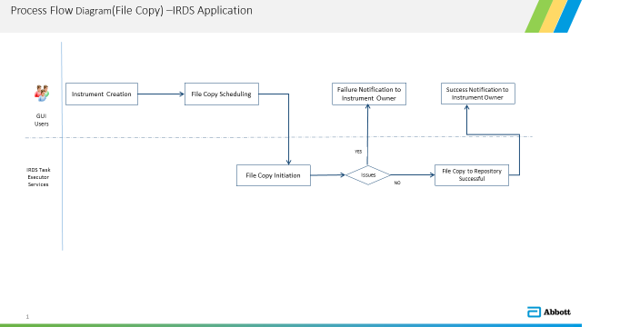

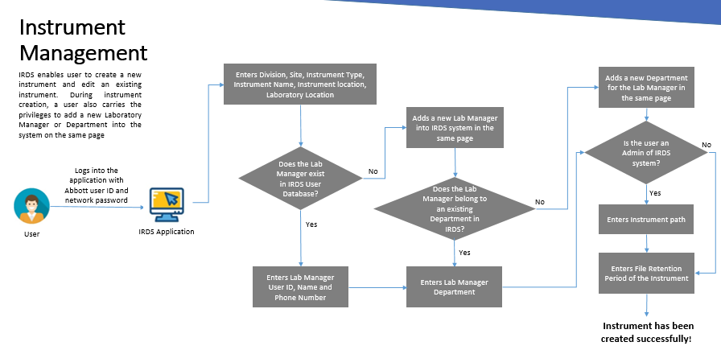 

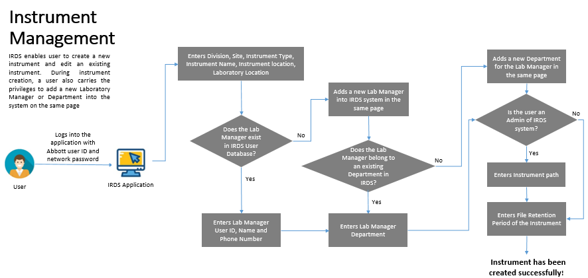

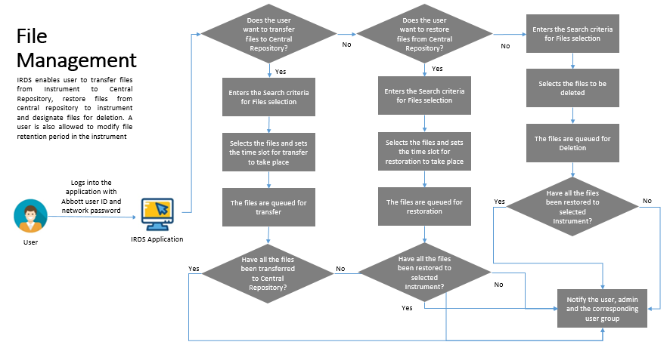

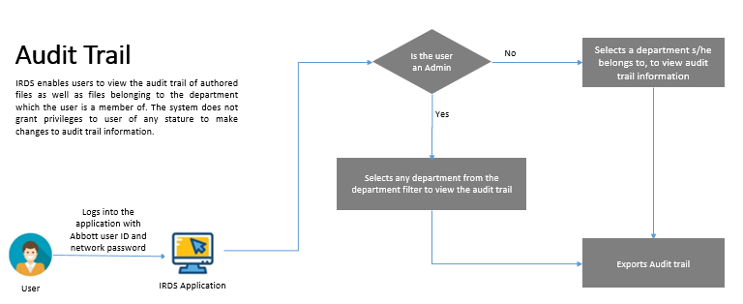

4.2 Business Module Description

The module wise information on IRDS is as follows:

**User Management-**

* Admin users can create and enable a new user in the application.
* These users can be deleted or disabled, and the details can be edited

**Department Management**-

* Admin users can create and enable a new department in the application.
* These departments can be deleted or disabled, and the details can be edited

**Instrument Management**-

* Users with Admin/Author/Laboratory Manager access can create and enable an instrument in IRDS and access the corresponding files.
* The details of the instrument can be edited

**File Management-**

* Users with Admin/Author/Laboratory Manager access can schedule the raw data files generated by research laboratory instruments to be transferred by the application on-demand basis to a central repository
* Users with Admin/Author/Laboratory Manager access can extend a file’s retention period in central repository
* Users with Admin/Author/Laboratory Manager access can restore the files from CR to a selected location on-demand basis. Users with ‘General User’ access can only view the files available in Central Repository
* Users with Admin/Author/Laboratory Manager access can designate files for deletion from CR

**Audit Trail-**

* Users with Admin/Author/Laboratory Manager access can view the audit logs in IRDS application.

**4.3 User Information, Roles & Privileges**

|  |  |
| --- | --- |
| Roles | Privileges |
| **Administrator (Administrator)** | Create/Edit/Disable/Delete users in IRDS |
| **User (Author/Laboratory Manager)** | Access the files associated with the group they belong to. |
| **View Only** | view the files associated with the group they belong to |

**4.4 Business Critical Events**

|  |  |  |  |
| --- | --- | --- | --- |
| Business Activities | Target Timelines | Impacted Applications | Business Groups involved |
| User Recertification | Yearly | IRDS | IRDS Support Team and GAA |

5.0 Application Overview

IRDS acts as a transfer medium between an Instrument PC and a Central Repository.

5.1 System Architecture

The IRDS is a web-based application that is developed using JAVA 1.8 and Hibernate and is hosted in Apache Tomcat. The system uses Oracle 12C Database server which serves as a data repository. The Central repository used in the application is NAS Drive. The application has four environments Production, validation, development. All the database and application servers are virtual. IRDS has no upstream or downstream application(s).

|  |  |  |  |
| --- | --- | --- | --- |
| Sr. No. | Service Name | Execution Trigger | Rule/Criteria |
| 1 | File Archival(Transfer) | After every 5min | 1. File transfer request can be created 30 min after the current time. 2. File transfer slot i.e. From and To date-time should have at least 30min difference. 3. Maximum of 5 request can be created for the same time interval for multiple users, if any. |
| 2 | File Restore | 6 Hours interval (4 times a day) | 1. File should be archived to the CR (Central Repository) through file transfer request i.e. user can only restore those files which are archived to the CR. 2. Multiple restore requests can be created for the same file.  3. User can restore file(s) to either original instrument or other instrument in a user group. |
| 3 | Deletion | Every day, 1:00am morning (once in a day) | 1. File should be archived to the CR (Central Repository) through file transfer request i.e. user can only designate those files which are archived to the CR for deletion. 2. The file for which Deletion request is created will be deleted after the Deletion service execution. 3. File will be eligible for deletion after its retention period is expired (120 days default) from the CR. |

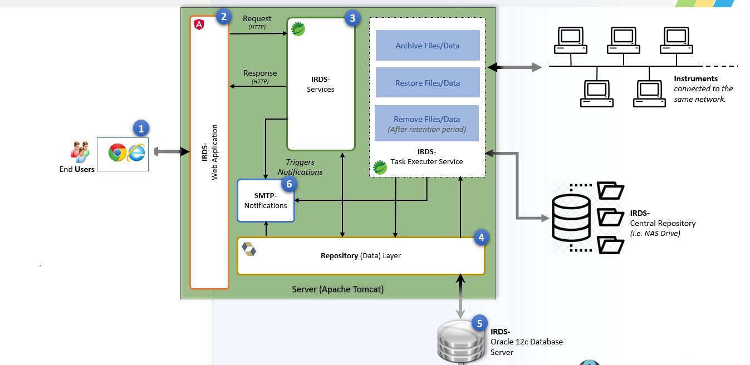

Refer document “IRDS System Architecture Description.doc” in NPV (LC-S 01152.000) for more details.

5.1.1 Environment Details

|  |  |  |  |  |
| --- | --- | --- | --- | --- |
| Server Name | URL | Environment | Server Type | Hosting Location |
| CWA101862P | http://addirds.oneabbott.com/IRDS/login | Production | Application Server | Lake County |
| CWA101865Q | http://addirds.qa.oneabbott.com/IRDS/login | QA | Application Server | Franklin County |
| CWA101861D | <http://addirds.dev.oneabbott.com/IRDS/login>. | Development | Application Server | Franklin County |
| CUQ102021P | NA | Production | Database Server | Lake County |
| CUQ102020Q | NA | QA | Database Server | Franklin County |
| CUQ102022Dc | NA | Development | Database Server | Franklin County |

5.1.2 Database Model

The table relationships in the db model are listed below.

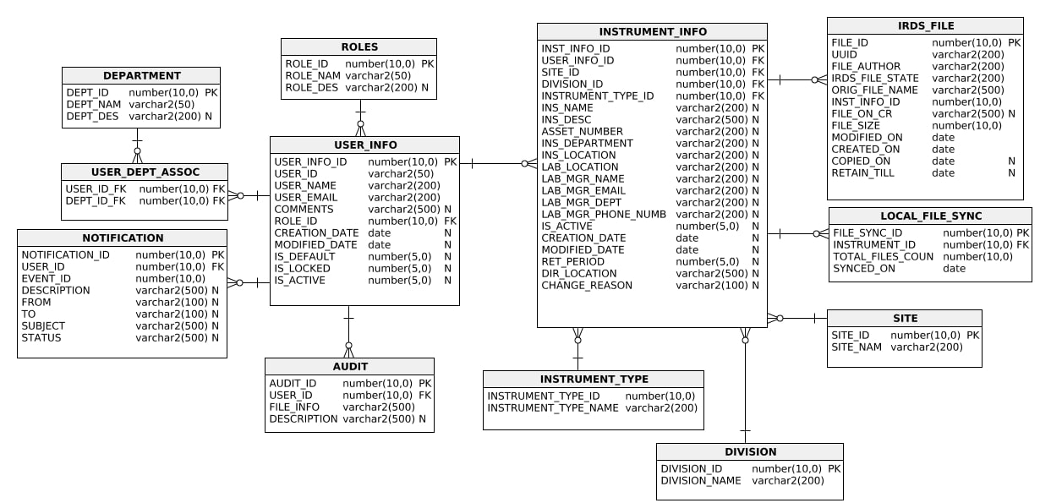

* + 1. Integration Details

There are no external interfaces interacting with the IRDS system.

5.1.4 Third Party Components

The application does not have any third-party components.

**5.2 Regulatory & Compliance Parameters**

|  |  |
| --- | --- |
| GxP Regulations | |
| Is it GxPapplication (GMP, GLP, GCP)? | **GxP _________** **Non-GxP** |
| If GxP, GAMP 5 Categories (1/3/4/5)? | Infrastructure Only (Category 1)  Standard System (Non-Configurable) (Category 3)  Configurable System (Category 4)  Custom or Bespoke System (Category 5) |
| Availability of ‘System Risk Assessment Report’ or Compliance Determination Document (Yes/No).  If yes, please provide the document path. | No |
| The location/path of all validation documents (Infrastructure qualification documents, application level validation documents (IQ, OQ, PQ – all versions + user manual, etc.)) | LC-S 01152.000 |
| As part of the maintenance and support activities, before applying a change/upgrade to a GxP system, if you identify that the existing infrastructure or application is not validated, how do you proceed with the required change or upgrade?  Define Change. | The respective team will be contacted to create qualification documents; on completion and approval of such qualification, the current change or upgrade will be performed.  Thereis no such check points being followed.  Any other alternate process: ___________ |
| Additional Comments |  |
| SOX Regulations | |
| Does the Application need to be SOX Compliant? | Yes No |
| If yes, the availability of SOX control objectives |  |
| Additional Comments |  |
| Statements on Standards for Attestation Engagements (SSAE) | |
| Does the application come under SSAE purview? | Yes No |
| If yes, the availability of SSAE related documentations |  |
| Additional Comments |  |
| Any other regulations or controls to be complied with? | Yes No |
| If yes, list. | 1.  2. |

* 1. **Process and Procedures**

|  |  |  |
| --- | --- | --- |
| Reference of Process and Application Documents | | |
| Name | Version | Location |
| Incident Management Process Handbook | QC10.21 Incident Management Process | ISO train |
| Problem Management Process Handbook | QC10.23 GIS Problem Management Process | ISO train |
| Change Management Process Handbook | As such, handbook is not  available for problem  management process,  however, the process  followed is as per the  problem management  training available in  ISOTrain stipulated by  Abbott  **Change Management**  **Tool: Serena Business**  **Manager** | http://mashup/tmtrack/tmtrack.dll?LoginPage&T  emplate=loginform&ParamsInUserCache=10.25  2.192.21121342  CBT-DDNPSITSBM : SBM Non-Product  Software Problem Reporting  CBT-PPC-NPSIPD : Non Product Software  Defect Management  SBM tool will be used for Defect Tracking Purpose |
| Release Management Process Handbook | Not Available | NA |
| Business Process Understanding Handbook | Not Available | NA |
| Application Process Handbook | Version 1 | M-Files |
| Application Architecture Document | Version 2 | NPV(LC-S 01152.000) |
| Application Design Document | Version 2 | NPV(LC-S 01152.000) |
| Application Regression Pack | Not Available | NA |
| Configuration Management | Not Available | NA |
| Defect Management | AQ090506.A | ISO TRAIN |
| Archival & Retention Policy (or period) | Not Available |  |

6.0 Application Onboarding Requirements

6.1 Application Level Training

There are no application level specific trainings available and trainings will be provided by business for the users who needs access to the system and KT will be provide for the new application support person.

* 1. Application Access & Onboarding

User Access/onboarding falls under the business scope and user gets their access through

IIQ ([https://iiq.abbott.com](https://iiq.abbott.com/)) for their specific security group.

|  |  |
| --- | --- |
| **Role** | **AD Security Group** |
| Admin | APP-ADD-IRDS-ADMIN-PR |
| Author/LabManager | APP-ADD-IRDS-AUTHOR-LABMGR-PR |
| Read-Only | APP-ADD-IRDS-READ-ONLY-PR |

7.0 Scope of Maintenance Operations

7.1 In Scope Activities

* + 1. Incident Management
* All the tickets related to technical and functional issues for IRDS are routed to the below queue

ADM-GLBL-COG Product Dev & Approval Non-Critical App Support

* All database related tickets should be routed to the queue

ADM-GLBL-COG SQL DBA Non-Critical App Support

`

**SLA Details:**

|  |  |  |  |  |
| --- | --- | --- | --- | --- |
| **SLA/Priority** | **Response SLA** | | **SLA / Priority** | **Resolution SLA** |
| **Priority** | **Primary Hours** | **Secondary Hours** | **Priority** |
| P1 | 15 min | 60 min | P1 | 8 hours |
| P2 | 15 min | 90 min | P2 | 2 days |
| P3 | 2 hours | 4 hours | P3 | 6 days |
| P4 | 4 hours | 8 hours | P4 | 10 days |

* + 1. Change Control
    - Any changes made to production environment must also be made to QA environment such that both QA and Production environments remain in sync.The following are the type of changes.
      * Application configuration changes
      * Data changes
      * Database indexing and spacing
    - Changes are logged in SBM

<http://mashup/tmtrack/tmtrack.dll?LoginPage&Template=loginform&ParamsInUserCache=10.252.96.193_4107242986>

7.1.3 Defect / Enhancement Management

* + - Defect and Enhancements are logged using SBM (Serina business Manager).

<http://mashup/tmtrack/tmtrack.dll?LoginPage&Template=loginform&ParamsInUserCache=10.252.96.193_4107242986>

7.1.4 Batch Job Execution & Monitoring

There are no batch jobs for IRDS system,

7.1.5 User Management &Recertification

Recertification is carried out by the combined efforts of GAA team and support team. It is carried out once in a year.

7.1.6 System Backup and Restoration

* Back up: Daily Full Backup of DB is done; Log Update is done every hour.
* Point of contact in case of any restoration needs: **CTSOracleDBA** Group

7.1.7 Disaster Recovery

There are no disaster recovery documents available for this application but the Business Impact Assessment for IRDS project is stored in NPV LC-S 01152.000

7.1.8 Application Monitoring

Below components of IRDS application have been monitored by Application team

|  |  |
| --- | --- |
| **Monitoring Type** | **Monitoring Parameters** |
| Baseline IS Monitoring | CPU usage above 90% |
| Database Storage Usage Alert | Low c drive space. |

7.1.9 Application Maintenance

Standard maintenance followed by the windows team.

7.1.10 Application Patching

Standard maintenance followed by the windows team.

7.1.11 Outage Planning

If there is a planned maintenance, BRM/Business team will send communication to User Group. Planned maintenance will be tracked in the [Planned Maintenance tracker](https://abbott.sharepoint.com/teams/gis-ctsbssms/CentralDashboard/_layouts/15/start.aspx#/Lists/Planned%20Maintenance/AllItems.aspx).

7.1.12 Licence Management

There are no Licence constraint.

7.2 Out of Scope Activities

Any requirements not documented in the URS are categorized as out of scope

7.3 Site and Regional Differences

There is no Site and Regional differences for IRDS.

7.4 Vendor Agreements

There is no vendor for IRDS application.

7.5 Support Dependancy Matrix

|  |  |  |  |
| --- | --- | --- | --- |
| Dependent Group or Team | Resolver Group | Contact Number | Email ID |
| Application Team | ADM-GLBL-COG Product Dev & Approval Non-Critical App Support | NA | DG-ADD-IRDS-SUPPORT-GROUP@abbott.com |
| Database Support | ADM-GLBL-COG SQL DBA Non-Critical App Support | NA | [ctssqldba@abbott.com](mailto:ctssqldba@abbott.com) |

7.6 Key Contacts

|  |  |  |
| --- | --- | --- |
| Key Contacts | Role | eMail Id |
| ADD IRDS support team | Application Support | DG-ADD-IRDS-SUPPORT-GROUP@abbott.com |
| BTS IT Support Owner | Support Owner | Access the Application Portfolio Management Tool (HOPEX) for current support owner name |

7.7 Knowledge Repository

|  |  |
| --- | --- |
| Documents/Materials | **Reference Links** |
| Knowledge articles for known issues | [http://itsm.oneabbott.com](http://itsm.oneabbott.com/) |
| Application Source code: | Azure Devops:  <https://dev.azure.com/abbott/_git/Instrument%20Raw%20Data%20Storage> |
| All IRDS related documents | LC-S 01152.000 |

END OF DOCUMENT